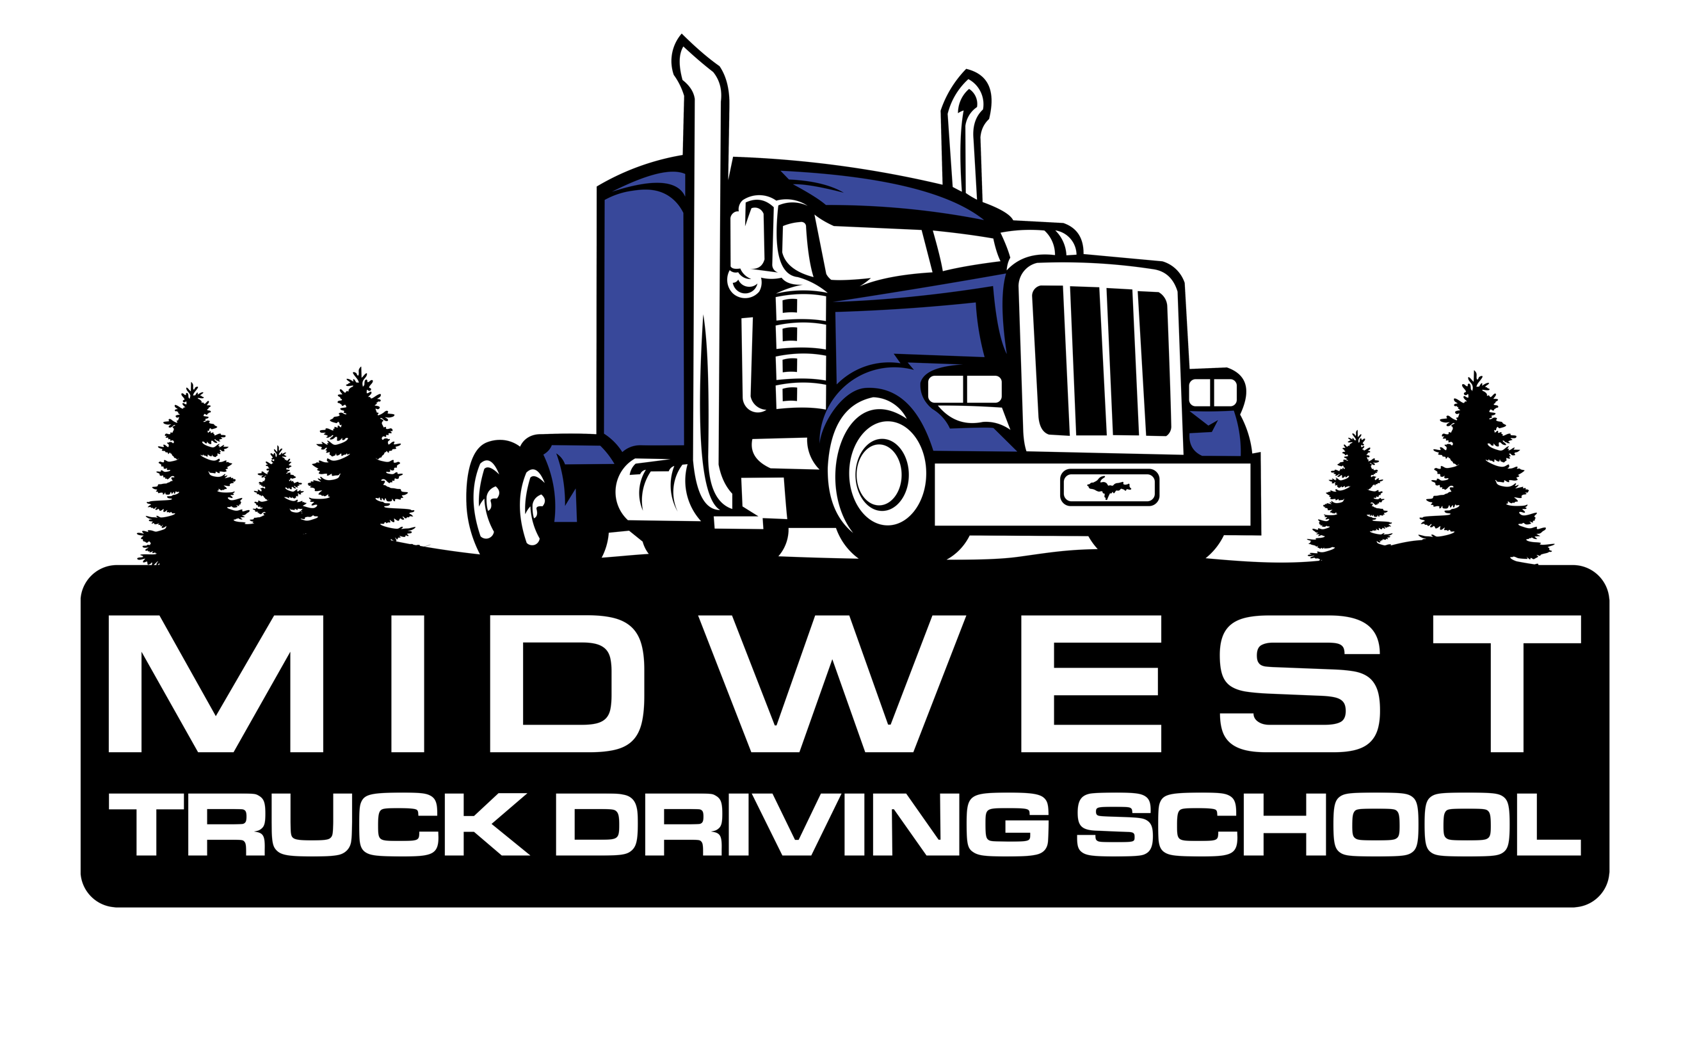

School Catalog
Date of Publication: August 1st, 2021 – Issue 16
Facility Code: 2-5-2095-22
Provider Number: P000613
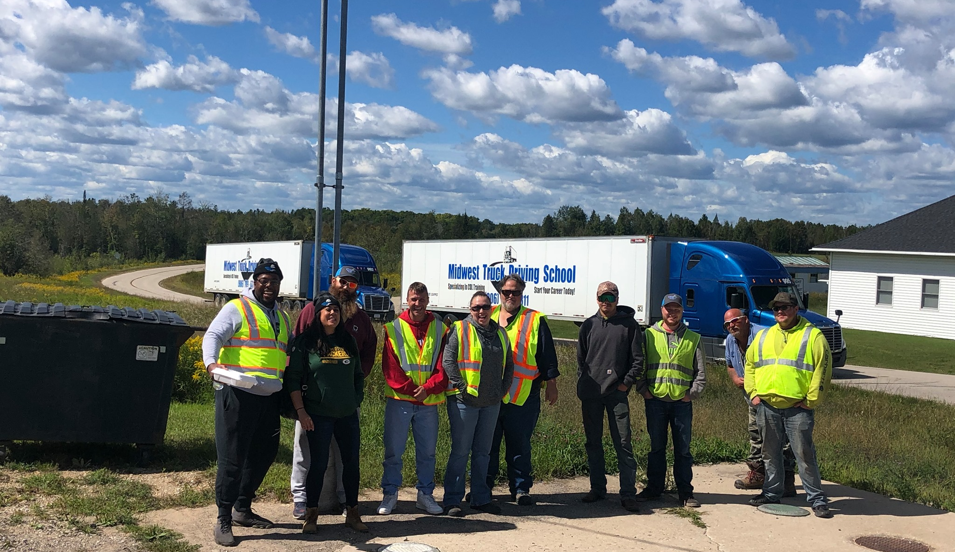

1519 N 26th Street Escanaba, MI 49829
Phone: (906) 789-6311 Toll Free (800) 377-5567 Fax: (906) 789-6317
info@midwesttruckdrivingschool.com
www.MidwestTruckDrivingSchool.com

2021/ 2022 Class Start and End Dates

160-Hour Class A CDL Course
Courses start on Monday’s unless there is a conflict with a Federal Holiday in which the class would start on the Tuesday following the holiday. Course make up days will be held on Saturdays, through take-home assignments or homework, on nights, or made up the following week.

START DATE COMPLETION DATE
June 1st, 2021 June 25th, 2021
June 28th, 2021 July 23rd, 2021
July 26th, 2021 August 20th, 2021
August 23rd, 2021 September 17th, 2021
September 20th, 2021 October 15th, 2021
October 18th, 2021 November 12th, 2021
November 16th, 2021 December 10th, 2021
December 13th, 2021 January 7th, 2022
January 10th, 2022 February 4th, 2022
February 7th, 2022 March 4th, 2022
March 7th, 2022 April 1st, 2022
April 4th, 2022 April 29th, 2022
May 2nd, 2022 May 27th, 2022
May 31st, 2022 June 24th, 2022
June 27th, 2022 July 22, 2022
July 25th, 2022 August 19th, 2022
August 22nd, 2022 September 16th, 2022
September 19th, 2022 October 14th, 2022
October 17th, 2022 November 11, 2022
November 14th, 2022 December 9th, 2022
December 12th, 2022 January 6th, 2023

40-hour Class B, Class A Refresher, and School Bus/ Passenger Endorsement CDL Courses

START DATE COMPLETION DATE
June 28th, 2021 July 2nd, 2021
July 26th, 2021 July 30th, 2021
August 23rd, 2021 August 27th, 2021
September 20th, 2021 September 25th, 2021
October 18th, 2021 October 22nd, 2021
November 16th, 2021 November 20th, 2021
December 13th, 2021 December 17th, 2021
January 10th, 2022 January 14th, 2022
February 7th, 2022 February 11th, 2022
March 7th, 2022 March 11th, 2022
April 4th, 2022 April 8th, 2022
May 2nd, 2022 May 6th, 2022
May 31st, 2022 June 4th, 2022
June 27th, 2022 July 1st, 2022
July 25th, 2022 July 29th, 2022
August 22nd, 2022 August 26th, 2022
September 19th, 2022 September 23rd, 2022
October 17th, 2022 October 21st, 2022
November 14th, 2022 November 18th, 2022
December 12th, 2022 December 16th, 2022

There are no classes held on the following holidays: New Year’s Day, Memorial Day, Independence Day, Labor Day, Thanksgiving, or Christmas Day. New Year’s Eve and Christmas Eve are optional days. Instructors will be on the premises for those wishing to receive additional practice time, but students will not be penalized for not attending class these days.

Institutional Philosophy
Midwest Truck Driving School is an institution that offers a truck driver training program for Class A, Class B, and Class B School Bus/ Passenger Endorsement Commercial Driver Licenses (CDL’s). The School is Directed by individuals who understand occupational education and the transportation industry. We have taken this valuable knowledge and experience and made it available to our students. We have been committed to training professional truck drivers since 1998 and have one of the finest entry level commercial driver training programs in the country.

Institutional Mission
The mission of Midwest Truck Driving School is to provide a quality occupational learning opportunity for adults. This is done through our program that is innovative, convenient, accessible, and will allow students to gain the knowledge and skills necessary to enter the transportation industry as an entry level professional driver. This philosophy requires a commitment to our students, the transportation industry, and to the motoring public. A commitment that mandates a careful screening to ensure that students have the ability and aptitude to master the necessary knowledge and skills required to safely operate a Commercial Motor Vehicle, and to achieve employment in the industry.

Licensing and Approvals
The Education Approval Boards of Michigan and Wisconsin have approved Midwest Truck Driving School to operate as a truck driver training program for students in Michigan and Wisconsin. We have also met the approval of several major transportation companies and are members of the Michigan Driver and Traffic Safety Education Association, Women in Trucking Association, Michigan Center for Truck Safety, Michigan Trucking Association, Accredited through the Better Business Bureau with an A+ professional rating, and are certified through the Commercial Vehicle Training Association (CVTA). We are also an approved training facility for the GI Bill, Michigan Rehabilitation Services, Upper Peninsula Michigan Works, Wisconsin Job Center, Sault Tribe of Chippewa Indians, and the MINGSTAP National Guard grant and tuition assistance programs.

Location, Facilities, and Equipment
Midwest Truck Driving School is located at 1519 North 26th Street Escanaba, MI 49829. This location houses the training facility, the administrative offices, and corporate offices. The facility provides classrooms, offices, a student lounge, and a personnel lounge. The classroom can accommodate up to 16 students. It has ample space to facilitate lectures, workshop activities, and general classroom instruction. The classroom portion utilizes audio and visual equipment, projectors, projector screens, televisions, student computers, replica trucks, replica life-size logbooks, instructional videos, and dry erase boards. All these pieces of equipment assist with the presentation of power points, educational videos, educational presentations, and hands-on demonstrations.

The adjacent range, which is accessible via the student entrance at the rear of the building, provides ample space for the students to practice their pre-trip vehicle inspections and their range maneuvers. On the range, they will practice the straight line back, the forward stop, off-set backing, alley docking, blind side backing, coupling/ uncoupling procedures, and tandem sliding. We also utilize a portion of the close-by UP State Fairgrounds that has an asphalt lot. We use this space to give students an idea of how different road/ lot surfaces affect maneuvers. We also use this space for the use of the state’s only Skid Pad training, where the students learn the proper procedures for handling a vehicle in adverse weather conditions emulating different skids and losses of traction.

Midwest Truck Driving School utilizes and maintains tractor-trailers like the units that are currently being operated during daily operations within the trucking industry. All the equipment that the students will use employ manual transmissions, both synchronized and non-synchronized, in order to ensure the most inclusive training that they can receive. All School vehicles are equipped with full air brakes.

Administration
Our instructors are our greatest assets here at Midwest Truck Driving School. With their knowledge gained as experienced Class A CDL Professional Drivers, with various associate’s and bachelor’s degrees, our instructors are highly skilled and qualified to train students and assist them in meeting the goals of their new career. All on-the-road instruction is performed on designated and approved routes that were selected to allow the student to progress through various degrees of difficulty as their competencies and skills are mastered.

Admissions
Students meeting the admissions criteria as determined by the Department of Motor Vehicles of the Secretary of State will be admitted to the School without regard to race, color, creed, sex, religion, national origin, political affiliation, or sexual preference. The age restriction for the course is mandated by the FMCSA. Some states allow an individual between the ages of 18 and 21 to drive in intrastate commerce, meaning within the state of their licensure. Per the regulations of the FMCSA, an individual must be aged 21 or over in order to operate a commercial motor vehicle in interstate commerce, meaning across state lines.

All applicants must be at least 18 years of age (or turning 18 prior to the first day of their course), possess a valid driver’s license, have an acceptable driving record, pass a DOT physical, pass a DOT drug screen, and meet all driver qualifications as required by the Federal Motor Carrier Safety Regulations 49 CFR Part 40. Please note, that within the State of Michigan, marijuana use is legally acceptable. However, as it is not federally legal, its use is not permissible while operating a commercial motor vehicle and therefore will be screened for during the DOT drug screening. All CLP holders will be queried within the FMCSA’s Drug and Alcohol Clearinghouse as per the requirements of 49 CFR § 382.701.

A high school diploma is preferred, but not required for admission to Midwest Truck Driving School. All applicants must have the ability to read, write, and speak the English language and do simple arithmetic. Applicants that are applying for the week-long refresher course must have held their CDL within the previous two (2) years, and will be required to demonstrate and/or verify prior training or experience.

Those who are interested in attending the School should contact us and speak to the admissions representative. They can be reached at (906) 789-6311 or toll free at (800) 377-5567.

Applicants must be interviewed by an admissions representative, complete an enrollment application, complete an enrollment contract, and submit other information required to satisfy each of the admission requirements unless they are waived by the school. All prospective students are encouraged to visit the school for a personal tour of the training facility.

Four-week classes begin every four weeks on Mondays and the cut-off for admission into a specific class is the Wednesday immediately preceding the Monday that the class starts. One and two weeklong classes typically start on Mondays; however, we do try to accommodate our student’s schedules. The admission staff will make every effort to enroll students who have not completed the admissions requirements by the Wednesday prior to class.

Class Sizes and Instructor Ratios
The courses are structured for students with the following instructor to student ratios, based on the maximum class size of 16 students:

Classroom 1:16 Instructor to Student Ratio
Range (Off-Road) 1:6 Instructor to Student Ratio
Street (On-Road) 1:4 Instructor to Student Ratio

Course and Training Objectives
Midwest Truck Driving School offers the following courses and training programs:

Four-Week Class A CDL Tractor-Trailer Course:
The objective of the 160 Hour CVTA Certified Tractor-Trailer Driver Training Course is to provide the student with the skills, competencies, and knowledge to pass their state’s licensing exam and enter the trucking industry as an entry-level professional driver. This is a comprehensive training program that is ideal for all people interested in the trucking industry, whether they have experience within the field or not. The curriculum includes both classroom and behind-the-wheel training yet focuses primarily on allowing students as much hands-on training as possible while still satisfying the requirements set forth by the Federal Motor Carrier Safety Association under the entry-level driver training requirements. The classroom portion of the training includes presentations from Department of Transportation Officials, Safety D3irector’s, Operation Lifesaver, and recruiters from various trucking companies. This course consists of 160 hours of combined instruction: on average this breaks down to 40 hours of classroom training, 70 hours of range training, and 50 hours of on-the-road (BTW) training. The four-week course meets Monday through Friday, 8:00 am to 4:30 pm with a half an hour allocated for lunch. If there are adverse weather conditions or extenuating circumstances that prevent training on a regularly scheduled day, additional training time will be offered to the students at no additional cost.

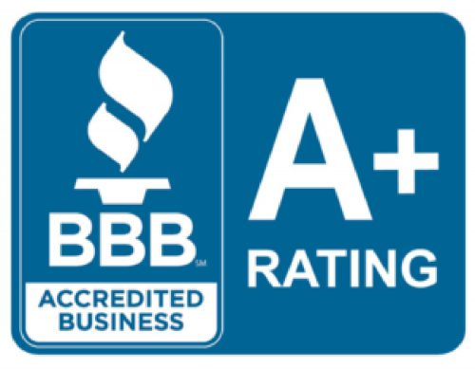
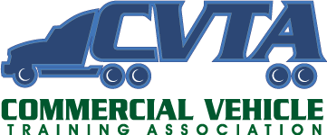

Curriculum Outline

Classroom Instruction | Range/ Class Instruction | Road/ Street Instruction
FMCSA Regulations | Vehicle Inspection | Pre-trip/ Post-trip Inspection
Vehicle Systems | Couple/ Uncouple | Shifting (Double-clutch)
Brake Systems | Turning Exercises | Expressway Driving
Skid Control | Backing Exercises | City Driving
Accident Procedures | Shifting/ Clutching | Lane Control/ Usage
Trip Planning | Slowing/ Stopping | Emergency Procedure
Drivers Logs and ELD’s | Signal Use | Speed/ Space Management
Hazard Perception | Safety Belt/ Safety Devices | Railroad Crossing
Visual Search DDC | Traffic Laws | Bridges/ Overpasses
Distractive Driving | General Driving Behavior | Road Signs/ Signals
Signs | Traffic Checks/ Search | Rural Streets

Tuition and Fees (Class A CDL)

Four-Week 160-Hour Class A CDL Tractor Trailer Course
DOT Physical and Drug Screen | $201.00
Commercial Learner’s Permit | $25.00
Books and Supplies | Included
Recruitment and Job Placement | Included
Skid Pad Training | Included
New Driver’s Toolkit | Included
Tuition | $4,990.00
Total Program Costs | $5,216.00

One Week 40-hour Class B Course:
The Class B CDL course consists of 40 hours of training at the Escanaba, Michigan training facility. It is five days long, starting Monday and going through Friday. The student is in class from 8am to 4:30pm daily with 30 minutes allotted for a lunch break. On average, the training time is broken into 10 hours of classroom training, 20 hours of range training including pre-trip inspections, and 10 hours of behind-the-wheel training. Due to the 14-day period between the issuance of the students CLP and their test date required by the Secretary of State, the student is required to get their CLP one week prior to the start of class. This prevents any delays with testing following the training period. The student is also required to obtain their DOT physical prior to the start of the course.

Curriculum Outline

Classroom Instruction | Range/ Class Instruction | Road/ Street Instruction
DOT Regulations | Vehicle Inspection | Pre-trip Inspection
Vehicle Systems | Traffic Checks/ Search | Shifting
Brake Systems | Turning Exercises | Rural Streets
Skid Control | Backing Exercises | City Driving
Accident Procedures | Shifting/ Clutching | Lane Control/ Usage
Expressway Driving | Slowing/ Stopping | Emergency Procedure
Signs | Signal Use | Speed/ Space Management
Hazard Perception | Safety Belt | Railroad Crossing
Visual Search DDC | Traffic Laws | Bridges/ Overpasses
Distractive Driving | General Driving Behavior | Road Signs/ Signals

Tuition and Fees

One Week 40 Hour Class B Straight Truck Course
Commercial Learner’s Permit | $25.00
DOT Physical and Drug Screen | $201.00
Books and Supplies | Included
Tuition | $2,500.00
Total Fees | $2,726.00

One Week 40-Hour Class B School Bus Course:
The objective of the one week 40 hour Class B School Bus Training Course is to provide the student with the skills, competencies, and knowledge necessary to pass the State licensing exam. This training also includes training for proper railroad crossing procedures and passenger discharge procedures. Due to the 14-day period between the issuance of the students CLP and their test date required by the Secretary of State, the student is required to get their CLP one week prior to the start of class. This prevents any delays with testing following the training period. The student is also required to obtain their DOT physical prior to the start of the course. The School Bus course also requires a Passenger endorsement on the students CLP which includes a separate state exam. The student must take the test for this endorsement at the same time they get their CLP. The passenger endorsement test is included in the tuition costs as described below.

Classroom Instruction | Range/ Class Instruction | Road/ Street Instruction
Regulations | Vehicle Inspection | Pre-trip Inspection
Vehicle Systems | Traffic Checks/ Search | Shifting
Brake Systems | Turning Exercises | Rural Streets
Skid Control | Backing Exercises | City Driving
Accident Procedures | Shifting/ Clutching | Lane Control/ Usage
Expressway Driving | Slowing/ Stopping | Emergency Procedure
Signs | Signal Use | Speed/ Space Management
Hazard Perception | Safety Belt | Railroad Crossing
Visual Search DDC | Traffic Laws | Bridges/ Overpasses
Distractive Driving | General Driving Behavior | Road Signs/ Signals

Tuition and Fees

One Week 40 Hour Class B School Bus Course
Commercial Learner’s Permit | $25.00
DOT Physical and Drug Screen | $201.00
Books and Supplies | Included
Recruiting and Job Placement | Included
Passenger Endorsement Training | Included
Tuition | $2,500.00
Total Fees | $2,726.00

Two Week Class B and School Bus/ Passenger Course
This program consists of 80 hours combined classroom, range, and behind-the-wheel training. This course is designed for the student to be able to safely operate both Class B Straight trucks and School Buses with proper passenger endorsement. It combines the curriculum of both courses. The course is broken down into approximately 10 hours of classroom training, 10 hours of pre-trip, railroad crossing, and passenger discharge training, 20 hours of range training, and 40 hours of road training. If there is adverse weather, additional training time will be offered to the student to make up the difference at no extra cost.

Classroom Instruction | Range/ Class Instruction | Road/ Street Instruction
Regulations | Vehicle Inspection | Pre-trip Inspection
Vehicle Systems | Traffic Checks/ Search | Shifting
Brake Systems | Turning Exercises | Rural Streets
Skid Control | Backing Exercises | City Driving
Accident Procedures | Shifting/ Clutching | Lane Control/ Usage
Expressway Driving | Slowing/ Stopping | Emergency Procedure
Signs | Signal Use | Speed/ Space Management
Hazard Perception | Safety Belt | Railroad Crossing
Visual Search DDC | Traffic Laws | Bridges/ Overpasses
Distractive Driving | General Driving Behavior | Road Signs/ Signals

Tuition and Fees

Two Week 80 Hour Class B & School Bus Course
Skills Test (State Test) | $175.00
Books and Supplies | Included
Recruiting and Job Placement | Included
Training/Equipment Rental | Included
Passenger Endorsement Training | Included
Tuition | $3,175.00
Total Fees | $3,350.00

One Week Tractor-Trailer Class A Refresher Course
The purpose of the one-week refresher course is to allow current CDL holders to stay up to date on constantly changing FMCSA regulations and to provide an opportunity for former CDL holders to regain their commercial license. For this course, it is required that you either currently hold a Class A CDL or have held one within the previous two years. Students attending this course will be required to obtain their CLP (commercial learner’s permit) and their DOT physical at least one week prior to the start of the course. This course is on average broken into 5 hours of vehicle inspection training, 15 hours of range training and 20 hours of on the road training. In case of adverse weather, extra time will be allotted for the student to receive ample practice time before their state skills test, if applicable.

Classroom Instruction | Range/ Class Instruction | Road/ Street Instruction
Regulations | Vehicle Inspection | Pre-trip Inspection
Vehicle Systems | Couple/ Uncouple | Shifting
Brake Systems | Turning Exercises | Expressway Driving
Skid Control | Backing Exercises | City Driving
Accident Procedures | Shifting/ Clutching | Lane Control/ Usage
Trip Planning | Slowing/ Stopping | Emergency Procedure
Drivers Logs and ELD’s | Signal Use | Speed/ Space Management
Hazard Perception | Safety Belt | Railroad Crossing
Visual Search DDC | Traffic Laws | Bridges/ Overpasses
Distractive Driving | General Driving Behavior | Road Signs/ Signals
Signs | Traffic Checks/ Search | Rural Streets

Tuition and Fees

One Week 40 Hour Class A Refresher Course
Final State Skills Test | N/A
Books and Supplies | Included
Recruiting and Job Placement | Included
Tuition | $2,325.00
Total Tuition | $2,325.00

Use of all necessary books and supplies, including handouts, are included in the cost of tuition. Textbooks are provided for the use of the student through the duration of the course but remain property of the School. All tuition and fees must be paid prior to or on the first day of class. Skills testing is administered by a third-party tester with no affiliation to the School or its employees. The various programs offered by the School do qualify for various financial assistance programs. Students who are using a private or public financial institution to pay their tuition must plan for them to have their payments prior to or on the first day of class.

Additional Costs
Students are responsible for making arrangements for room and board, if necessary, for the duration of the course. The School does provide the appropriate vehicle for their state skills test at the end of the course, the cost of which is included in the tuition. Students who wish to test outside of the State of Michigan are responsible for arranging the vehicle for testing and setting the test date and time themselves. As the final state test fee is included in the cost of the tuition, the student will be given a check for up to $175 made out to the skills tester for the cost of their skills test in the state of their choosing. Students are responsible for the costs of their CLP (commercial learners permit), their DOT physical, and the DOT drug screen.

Student Services
The School manages an off-site lodging facility and the admissions staff will assist the student in arranging any necessary housing. Every reasonable effort is made to help reduce the expenses for the student. Reference materials, supplemental tests, textbook, pre-trip verbal’s, diagrams, and other related materials pertaining to the course and program that they are enrolled in are available to the student. All students may request these materials at any time.

Student Records
The School maintains a permanent record for each student. The permanent records are confidential and only such agencies and individuals authorized by law are allowed access without written permission from the student. The school retains these records for a period of five years. Students may review their permanent record upon reasonable request to the School director. All such requests will be scheduled during regular School hours under appropriate supervision. Information requested by a potential employer will be required to have written consent by the student prior to the release of information.

A complete record of each student’s attendance and grades are maintained within the permanent records. Signed and dated photocopy of these forms represents an official transcript. One official transcript will be provided free of charge to the student. Students who have not satisfied their financial obligation to the School are not eligible to receive a transcript.
Attendance
Attendance is mandatory as part of the course requirements. Students are expected to attend all scheduled instructional hours. Please note that no classes are held on the following holidays: New Year’s Day, Memorial Day, Independence Day, Labor Day, Thanksgiving, or Christmas. New Year’s Eve and Christmas Eve, if they fall upon days of regularly scheduled class times, will be optional days. The students will not be penalized for missing these days and instructors and staff will be at the school for those wishing to attend.

Tardiness
Tardiness, or the incident of arriving late or leaving early, shall be recorded in the student’s record and accumulated as hours/days absent. Punctuality and time management are traits that the professional truck driver must possess. Three recorded incidents of tardiness shall be considered as one day of absence on the student’s attendance record.

Absences
Cumulative absences of more than two days (16 instructional hours) may result in termination, since such interruption may prevent the student from mastering the competencies essential to the course of study. Exceptions can be made on a case by case basis. The School realizes that there are extenuating circumstances that arise which may prevent a student from attending class such as a death in the family or medical emergency. These excused absences are at the discretion of the administration.

Leave of Absence
The school realizes that extenuating circumstances may arise where it would not be advantageous for the student to maintain enrollment in the program or there are circumstances where the student is required, by federal regulations, to discontinue training for a period. In such cases, upon written request and at the school director’s discretion, a leave of absence may be granted. A leave of absence must indicate a student’s sincere intention to resume his/her vocation. The student who is granted a leave of absence will be terminated from the school if the student does not enroll at the start of the next scheduled class or by the predetermined date agreed upon by the student and the school director. A student will be granted only one leave of absence.

Withdrawal and Re-Entry
The School Director may allow a student to voluntarily withdraw from a class and re-enter at a later date that may not interfere with the student’s training and is acceptable to both the student and the school. Students who are terminated may be allowed (depending on the reason for termination) to re-enter, at the School Director’s discretion, without losing any credit from prior training only one time at a future date determined by the School Director, but no earlier than 30 days from the student’s last day of attendance.

In case a student must be removed from training as a result of a positive drug or alcohol screen, in accordance with the FMCSA’s Clearinghouse, the school will assist the student in enrollment in a Substance Abuse Program with a Substance Abuse Professional. Upon completion of the SAP program, in accordance with CFR part 40, the student may resume their training at the point they were removed from training. There will be no added tuition for the student unless a period of three months has passed since initial enrollment in the SAP program. If it is a second offense, after the completion of the initial SAP program, the student will be dismissed from the course and tuition will be forfeited.

Make-Up Work
Any missed work must be completed by the end of the next instructional week.

Student Conduct
Students shall, at all times, conduct themselves in an exemplary manner in and out of the School. Midwest Truck Driving School is committed to the standard of professionalism required by employers in the industry and expects the same commitment from the students who are preparing for a career in the industry. As such, student may be terminated for any of the following incidents:

- Being under the influence of, or in possession of, intoxicating beverages or illegal drugs of any kind while on school property or in or around school equipment or the during any portion of the training period.
  - Note, alcoholic beverages will be permitted at the off-site lodging as long as it does not interfere with another student’s stay and if the student follows the FMCSA and school regulations that alcohol use is not permitted 4 hours before the start of safety sensitive functions, including classroom instruction.
  - If alcohol use is suspected or the student is believed to be under the influence of alcohol, law enforcement will be called, and a breathalyzer test will be performed. If a student is found to be in possession of an illegal substance, law enforcement will be called.
- Unsafe behavior or operation of equipment or the abuse of equipment.
- Possession of weapons, theft or stealing, fighting, or vandalism.
  - This extends to the school maintained off-site lodging and any hotels that may be used during the course.
- Excessive absenteeism or failure to complete make-up work that is required for program completion.
- Falsification of any of the School’s admission paperwork or applications for employment or applications for drivers licenses or permits.

The School is not responsible for injury or property damage incurred by a student as a result of the student’s own negligence, unsafe behavior, or other misbehavior or failure to strictly adhere to the School’s policies and procedures.

Student Grievances/Complaints
Student grievances and/or complaints will be referred to the School Director. Any grievances or complaints that cannot be resolved by the school director, may be addressed to the owner of the school. Complaints regarding training standards/methods that conflict with published curriculum standards can be addressed with the Educational Approval Board. The numbers for these boards are as follows:
Michigan – (517) 241-6860
Wisconsin – (608) 266-3185

If your state is not listed, the phone number can be requested from the school administrator and will be promptly provided.

Grading System
Student progress is constantly monitored and evaluated using the school’s performance standards and requirements of the state’s training requirements. Each student must maintain a cumulative grade average of at least 80% or better in each module (classroom, range, and road) of instruction and pass all tests and examinations that are administered. Monitoring is performed though the use of written tests, instructor evaluation or range maneuvers, vehicle inspections, and on the road training. Students must achieve an 80% or higher grade to pass the course. Any grade below 80% will result in a fail. A student is permitted to retake any tests and/or examinations one (1) time. The grade achieved in the last examination will be the grade credited.

The Grading Scale

GRADE LEVEL | PERFORMANCE DEFINITION | GRADE POINT AVERAGE
Excellent- A | 95% - 100% | 4
Above Satisfactory – B | 87% - 94% | 3
Satisfactory – C | 80% - 86% | 2
Unsatisfactory – D | 60% - 79% | 1
Fail – F | Below 59% | 0
Incomplete – I | Not Complete | 0
The minimum performance standards are:

- Students must maintain a cumulative grade average of at least 80% or better in each module (classroom, range, and road) of instruction and pass all tests and examinations administered on a pass or fail basis.
- Students must comply with the school’s admission, attendance, conduct, and other policies at all times during the course of instruction.

Graduation
The candidate for the certificate of completion must have successfully completed all specified requirements for the certificate and be free from all indebtedness from the school or have made satisfactory arrangements for the payment of tuition and fees. Upon graduation, the student will receive a certificate as evidence of the student’s successful completion of the course of instruction and Department of Transportation road test Certification granted by a third-party tester.

Placement and Employment
Midwest Truck Driving School provides free placement and job counseling assistance and services to students and graduates. Satisfactory completion of the program course work and the development of personal qualities, in conjunction with the necessary aptitude, attitude, and ability, are the first steps in the employment process.

State Regulations prohibit the school from guaranteeing a CDL, employment, or set wages.

Cancellation and Refund Policy
A student may cancel the enrollment agreement at any time. A written notice of withdrawal is not required except during the three-business day cancellation period. A student who does not attend classes or provide an explanation for seven (7) calendar days is considered to have voluntarily terminated. The school may terminate a student for insufficient progress, non-payment, failure to comply with rules and regulations, and other items that are noted in the catalog. This catalog gives specific details.

Refund Policy

At Least | But Less Than | Refund of Tuition
1% | 10% | 90%
10% | 20% | 80%
20% | 30% | 70%
30% | 40% | 60%
40% | 50% | 50%
50% | 60% | 40%
60% | ---- | No Refund

The school will make every effort to refund prepaid amounts for books, supplies, and other charges, when and if they should apply. A student will receive the refund within 30 days of termination date. If a student withdraws after completing 60% of the instruction, the school may refund a pro rata amount, if withdrawal is due to mitigating circumstances beyond the student’s control. Please note, the refund policy as outlined above pertains to only the tuition for the course that the student has attended and does not include incidental costs including lodging, CLPs, DOT physicals, or DOT drug screens.

Students Receiving Funding Under Title 38, United States Code
If a student fails to enter a course, or withdraws, or is discontinued therefrom at any time prior to completion, the amount charged will be an approximate pro-rata portion of the total charges for tuition, registration fees less than $10 (ten dollars) and other charges that the length of the completed portion of the course bears to its total length.

School Officials and Staff

The School’s legal name is Midwest Truck Driving Schools, LLC with our State of Michigan filed assumed name being Midwest Truck Driving School.

School Director – Joshua P. Barron MDOS Cert. – N004323
Director of Admissions – Kyle J. Barron MDOS Cert. – N004301
Office Administrator – Shauna L. Peltin
Head Certified Instructor – Thomas A. McKnight MDOS Cert. – N000566
Certified Instructor – Michael S. LaCasse MDOS Cert. – N004719
Certified Instructor – Roger J. Betzinger MDOS Cert. – N004546
Certified Instructor – Robert A. Lindahl MDOS Cert. – N004928
Accountant – Debra Hixon

This statement is to certify that this catalog is true and correct in content and policy.

Midwest Truck Driving School – Veteran Student Addendum

This catalog addendum applies to those students receiving U.S. Department of Veterans Affairs education (GI Bill) benefits while attending Midwest Truck Driving School.

Prior Credit Policy
Per 38CFR 21.4253(d)(3), previous training and experience will be considered and granted if appropriate, for veterans and other eligible students. Veterans must submit a copy of their DD214 discharge certificate and submit to an evaluation road test.

Attendance Policy
Students are expected to attend all classes. If circumstances prevent the attendance of a particular class, prior notification is expected in order to arrange make-up sessions. If attendance falls below 90%, VA benefits will be terminated. Students whose absences result from authorized mitigating circumstances, as determined by the school director, will not be terminated. Students who have been terminated from the school for unsatisfactory attendance may be re-admitted at the discretion of the director.

Conduct policy
Students must always conduct themselves in a respectable manner. Disruptive or inappropriate behavior deemed unsatisfactory conduct by school officials will result in termination of veteran’s educational benefits, and possible dismissal from Midwest Truck Driving School. Re-admittance after conduct dismissal requires reapplication to the school.

Academic Progress Policy
Students receiving VA education benefits must maintain a 75% or better grade average on each module of training (classroom, road, and range). Students also must complete all classroom assignments in a timely manner. Failure to meet these criterions will result in being placed on probation. If the criterions are not met by the end of the probationary period, VA education benefits will be terminated. Certification to VA for payment will not be resumed until the student has returned to a satisfactory academic status.

Pro-Rated Refund Policy for Veterans and Other Eligible Students
Per CFR 21.4255, Midwest Truck Driving School has a pro-rata refund policy for the refund of the unused portion of tuition, fees, and other charges in the event the veteran or eligible person fails to enter the course or withdraws or is discontinued there from at any time prior to completion.

Equal Opportunity Statement
Midwest Truck Driving School does not discriminate on the basis of race, color, religion, sex, disability, or national origin.

Program Completion
The student must satisfactorily complete the academic requirements of their chosen field and satisfy all financial obligations in order to receive a certificate.

Retention of Records
Midwest Truck Driving School will retain records and accounts of students receiving VA education benefits for a period of three (3) years following course completion. These records will be made available to the student upon request and certification.

VA Student Contact for Questions or Concerns
Shaftone Dunklin, Higher Education Consultant
Workforce Development
Michigan Department of Labor and Economic Opportunity
201 N. Washington Sq.
Lansing, MI 48913
Phone: 517-896-7805
Email: Dunklins@michigan.gov
Title 38 United States Code Section 3679(e) School Compliance Form
Effective August 1, 2019, the State approving agency, or the Secretary when acting in the role of the State approving agency, mandates SAA Schools have the following policies in effect:
NOTE: A Covered Individual is any individual who is entitled to educational assistance under chapter 31, Vocational Rehabilitation and Employment, or chapter 33, Post-9/11 GI Bill benefits.
Midwest Truck Driving School must permit any covered individual to attend or participate in the course of education during the period beginning on the date on which the individual provides to the educational institution a certificate of eligibility for entitlement to educational assistance under chapter 31 or 33 (a “certificate of eligibility” can also include a “Statement of Benefits” obtained from the Department of Veterans Affairs’ (VA) website – eBenefits, or a VAF 28-1905 form for chapter 31 authorization purposes) and ending on the earlier of the following dates:
- The date on which payment from VA is made to the institution.
- 90 days after the date the institution certified tuition and fees following the receipt of the certificate of eligibility.
Our educational institution (Midwest Truck Driving School) will not impose any penalty, including the assessment of late fees, the denial of access to classes, libraries, or other institutional facilities, or the requirement that a covered individual borrow additional funds, on any covered individual because of the individual’s inability to meet his or her financial obligations to the institution due to the delayed disbursement funding from VA under chapter 31 or 33.

